 | Edunity  Volume 2 Number 12, December, 2023  p- ISSN 2963-3648- e-ISSN 2964-8653  Doi:  https://edunity.publikasikupublisher.com/index.php/Edunity/index | 

THE MALE GAZE IN INTERNET ADVERTISING: CONTENT ANALYSIS OF AXE INDONESIA'S COLLABORATION WITH ENZY STORIA ON INSTAGRAM

Prasiani Purnama Sari
Fakultas Ilmu Sosial dan Ilmu Politik, Universitas Indonesia, Indonesia
E-mail: prasianipurnamasari@gmail.com

ABSTRACT
Instagram serves as a unique platform for businesses to engage consumers, market products, and convert visitors into buyers. While brands typically tailor their visual presentation to align with the brand persona and the sex/gender of their target audience, Axe Indonesia, in contrast, collaborated with Enzy Storia as an influencer on social media and even at off-network events, thereby indicating the presence of the male gaze in this collaboration. This qualitative study, employing a content analysis approach, aims to understand how the male gaze is reflected in Axe Indonesia's advertising content involving Enzy Storia on Instagram to generate engagement. The findings reveal the existence of visual representation, gender construction, and Enzy Storia's contribution to this collaboration. The male gaze in the visuals is further supported by audio elements, captions, and copy that objectify women
Keywords: Male Gaze; Engagement, Instagram; Internet Advertising; Visual

Introduction
Consumer engagement today is increasingly active online, seeking collaboration and interactivity with organizations. Consumer engagement represents cognitive, emotional, and behavioral investment in brand interactions. Social media facilitates interactive experiences and consumer participation within brand communities, such as providing comments, support, criticism, and sharing information with social connections (Anagnostopoulos et al., 2018)

The utilization of social media in building brand image and sustainable market share is highly crucial and substantial through the creation of shared and educational content. Social media marketing focuses on building relationships with consumers and capturing attention through product and service presentations. This marks a paradigm shift from traditional marketing where online users have more control over content than marketers (Kotler & Keller, 2016; Nadaraja & Yazdanifard, 2014; Hoffman & Novak, 2018; Markos-Kujbus & Gati, 2016; Lie et al., 2021; Naylor et al., 2014; in(Segumpan & McAlaney, 2023). Additionally, marketing on social media allows businesses to introduce brands/products quickly, easily, and effectively at low costs. Interaction with consumers through social media enables direct feedback and information exchange, distinguishing it from traditional marketing (Sumer & Parilti, 2023).

One of the commonly used social media platforms is Instagram, which serves as a unique platform for businesses to engage consumers, market products, and convert visitors into buyers (Adegbola et al., 2018). Instagram is also quite efficient in B2C (brand-to-customer) communication and helps brands connect through positive visual communication. By March 2017, many companies had Instagram profiles, with most users following business profiles. Over 120 million people use Instagram to visit company websites. About 49% of users look for appealing brands, while 14% are potentially inclined to click the "Buy Now" button. Companies utilize internet content monitoring tools to swiftly respond to target groups (Karwat, 2016; (Roth & Zawadzki, 2018).

Typically, a brand represents its visual appearance in line with the brand persona and even the sex/gender of its target audience (Lieven & Hildebrand, 2016). However, Axe Indonesia, a male fragrance brand, collaborated with Enzy Storia as a Key Opinion Leader in collaborations on social media and even at off-network events. This approach might have occurred because Axe Indonesia saw similarities in the interests or behaviors of its target audience, as advertisers on the internet can design and tailor advertising messages to suit individual targeted consumers (Fadli et al., 2023). Additionally, leveraging support from well-known figures (celebrity endorsement) has become a well-known tactic in marketing and advertising strategies worldwide (Knoll and Matthes, 2017; (Tian et al., 2022) and has long been recognized as a successful promotional approach in the context of modern advertising (Stafford et al., 2003; Wang & Scheinbaum, 2018; Yoon & Shin, 2017; in (Huang, 2021)

In addition to the fact that visitors are an audience already filtered based on their interests, internet advertising offers several other advantages compared to conventional advertising. These include enabling higher user engagement, allowing for direct feedback through customer surveys and online orders, the ability for small businesses to project a presence equivalent to larger companies, broader reach, and relatively lower costs (Anderson, 2019). On the other hand, interactions and advertising on the internet are influenced by gender differences, particularly in their cognitive and affective needs (Brunel & Nelson, 2003; Meyers-Levy & Maheswaran, 1991; Meyers-Levy & Sternthal, 1991; Phillip & Suri, 2004; Raman et al., 1995; Weiser, 2000; in McMahan et al., 2013, 64-65).

In place-based advertising, it has been found that gender impacts the amount of visual attention and behavior in viewing ads. It was found that men spend more time paying attention to promotional messages in advertising kiosks when there is a woman present. This indicates the influence of women in viewing ad stimuli, particularly about men (Suh et al., 2023).
Furthermore, advertising also contributes to the transmission and reinforcement of gender stereotypes by promoting "sexism" and altering perceptions of body image as something unhealthy and unacceptable (Fowler & Thomas, 2015) (Grau & Zotos, 2018). These marketing messages have long utilized the symbolism of the male and female body to influence their audiences in consumption activities. This is because advertisements influence how consumers behave, reflecting ongoing social trends, and serving as a place to learn normative expectations and build individual identities. By providing symbols and meanings that are acceptable to consumers, advertising facilitates the process of using and absorbing these symbols according to individual interests. Additionally, through body representation, advertising actively plays a role in creating and reinforcing existing gender identities (Moschis & Churchill, 1978; Eisend, 2010; Jagger, 2001; Tomlinson, 1990; (Fowler & Thomas, 2015) 359; Slater, 1997; Schroeder & Borgerson, 1998; in (Patterson & Elliott, 2002)

To build advertising campaigns that control subconscious thoughts and the body to drive product purchases, advertisers conduct in-depth research into the subconscious minds of potential consumers. General advertising direction to a wide audience is no longer carried out by advertisers to attract market segments, as it has been replaced by tailoring advertisements based on factors such as age, social class, gender, and race. Advertisers also indirectly perpetuate existing stereotypes and clichés by using implicit symbols to "incite" consumers' subconscious minds (A’yunin & Triastuti, n.d.). Thus, it is not surprising that some advertisements use women as objects to attract male attention.

In her work written in 1975, Mulvey outlined that women are forcibly directed to associate themselves with passive objects that become objects of the gaze, while male activity in film narratives is used to balance this aspect (Oliver, 2017). This gave rise to the concept of the Male Gaze, which refers to the sexual gaze that views women as passive objects fulfilling the erotic satisfaction of heterosexual men. In visual art, this concept reflects patterns of object placement that often position the viewer in a "masculine" stance to appreciate the artwork. Theorists analyzing nude paintings and Hollywood films have concluded that women in art are often presented as objects of attraction, with the role of the observer assumed to be more active, aligning with masculinity (BAGASAYU, 2021). Women's identities, thoughts, and sexual impulses are themselves often disregarded to fulfill male sexual desires (JS, 2019). Thus, it can be concluded that this concept empowers men while objectifying women.

The Male Gaze can be observed through the contrast between women's actions and inaction. Additionally, the Male Gaze can be created through the focus of the camera. When associated with audio-visual media, the camera serves as a representation of the male gaze, highlighting women's bodies from top to bottom, capturing body parts, and moving towards close-up shots of various parts of the female body, particularly the face. The camera transforms the subject into an object (Oliver, 2017). Not only in films, the Male Gaze is also present in various other media, such as social media. Research (Oliver, 2017) shows that social media platforms like Facebook, Snapchat, and Tinder are seen as contributors to the culture of the Male Gaze, as they objectify and degrade young girls and women.

Axe is one brand that frequently uses the allure of women in its advertisements. This can be seen in numerous Axe commercials, both aired on television and online, depicting women being attracted to men wearing Axe cologne. Although it has adapted to Indonesian culture, Axe still employs the concept of using women in advertisements similar to its global versions (Becker-Herby, 2016)

Axe, or LYNX, is a leading brand in the men's grooming industry produced by Unilever and is globally recognized. The brand offers various products such as body spray deodorants, deodorant and antiperspirant sticks, shower gels, and hair care products. Launched in 1983 in France under the name Axe, the primary goal of the brand is to provide exceptional fragrances for men in their everyday lives, with the hope of enhancing their attractiveness in dating. The brand's success quickly spread to Latin America, Asia, and Africa. Recently, China and Vietnam have become the latest markets to benefit from Axe's presence. In recent years, Axe has become the world's best-selling men's cologne, solidifying its position as a leader in the mass perfume business through collaborations with several leading perfumers (Axe.id., 2023)

In Indonesia, Axe products have been introduced for over 30 years and have become the preferred choice of body spray for many men. Most recently, a new version of Axe Body Spray was launched with Dual Action technology that effectively combats body odor and provides a refreshing scent, even when the user sweats. Axe fragrances are specially formulated for the Indonesian climate, ensuring long-lasting durability and providing a fresh aroma favored by Indonesian men (Axe.id., 2023)

On December 7, 2022, Axe Indonesia began its collaboration with Enzy Storia, starting with a post showing Enzy Storia following Axe Indonesia on Instagram and a teasing caption, "Suddenly got a notification that makes life smell even better 🫠 How about having fun with @enzystoria?". The next day, Axe Indonesia posted a video clip - with the full video uploaded on YouTube - featuring an opening scene of Enzy Storia flipping her hair and giving a seductive look. The video portrays that "Mr. Handsome" can live freely, such as cutting the line and being served directly by Enzy Storia, even though the people who queued earlier protested. However, it is "Mr. Fragrance" who can attract women, including Enzy Storia. The first two posts of Axe Indonesia's collaboration with Enzy Storia already indicate the use of women as objects of attraction to engage the Axe Indonesia target audience.
Therefore, this study aims to understand how the male gaze is reflected in Axe Indonesia's advertising content involving Enzy Storia on Instagram to generate engagement. This can be beneficial for marketers and practitioners to better understand the relationship between advertising and gender and to identify focal points that may indicate the Male Gaze. Thus, the objectification of women in advertisements can be avoided.

Research Method
This study uses a qualitative research approach because the data used in this study is included in the category of non-metric or qualitative data. This type of data can be used for classification and description but cannot be quantitatively measured (Fellows & Liu, 2021). In addition, the study did not use statistics in the analysis or findings. This approach uses textual data and images, has unique data analysis steps, and uses a variety of designs. Researchers' comments on their role and self-reflection (reflexivity), as well as the qualitative strategies used, are also present in qualitative approaches (Creswell & Creswell, 2017)

This research was conducted using documentation data collection techniques. The method used in this study is content analysis, which is a systematic and objective method to describe and measure certain phenomena from verbal, visual, or written data. It emphasizes the meaning, intention, consequences, and context of the data.

Result And Discussion
This chapter presents the research findings related to the male gaze in the collaboration between Axe Indonesia and Enzy Storia on Instagram. These findings provide a comprehensive overview of the male gaze in internet advertising, as well as the implications arising from the male gaze present in the collaboration.

After analyzing the content of the collaboration between Axe Indonesia and Enzy Storia on Instagram, it was found that the collaboration included a digital video clip with its full version aired on YouTube. Additionally, there was an event called "Axe Helps Enzy Find a Fragrant Boy" a collaboration between Enzy Storia, Axe Indonesia, and Indomaret, where Enzy Storia held meet and greets at three Indomaret locations around Jakarta. The requirement to participate in the event was to purchase any two Axe products at Indomaret, keep the purchase receipts, comment "Ready to be Axe-scented" tagging @axe.id and @indomaret in the post, and the winners would be contacted by Indomaret on Instagram. This event provided prizes such as a meet and greet with Enzy Storia and the opportunity to win tickets to a Sheila on 7 concerts, an iPhone 14, and a JBL Clip 3.

Not stopping there, Axe Indonesia also provided giveaway prizes of tickets to the Sheila on 7 concerts and a "fun time with Enzy Storia". To win these prizes, the audience was asked to use an Axe filter and provide pickup lines. Similarly to the collaboration between Axe Indonesia and Indomaret, Axe Indonesia also held a similar event with Alfamart. One interesting aspect of this collaboration was the mention of a prize of "being checked out by Enzy" in the content image on Axe Indonesia's Instagram.
In the visuals posted by Axe Indonesia on its Instagram, there was no mention of the gender requirements for participation in these events. However, all these events consistently featured the phrase "Fragrant Boy," implicitly indicating that the events were intended for men. Furthermore, in the event of the giveaway of Sheila 7 concert tickets and "fun time with Enzy Storia," the Axe Indonesia admin stated in a comment that the terms and conditions applied stipulated that the event participants must be male Indonesian citizens aged over 17 years.

Picture 1. Reply to the comment from Axe Indonesia

After conducting coding on the Instagram content collaboration between @axe.id and Enzy Storia, it was found that there is an identification of visual representation where Axe Indonesia's advertisements in collaboration with Enzy Storia on Instagram tend to use visual representations that position women as sexual and passive objects, focusing on their body parts and physical attractiveness. Furthermore, there is also a construction of gender that is formed because these advertisements reinforce traditional gender stereotypes by depicting men as active observers and women as objects of gaze, emphasizing the dominant role of men in the context of sexual life. The presence of the male gaze in this collaboration is further strengthened by Enzy Storia as she contributes to creating or reinforcing the narrative of the male gaze in Axe Indonesia's Instagram advertising content.

Visual Representation:
Although there are visuals featuring Enzy Storia with women in videos and images on Axe Indonesia's Instagram, no visuals were found showing intimate interactions between Enzy Storia and these women. This is in contrast to the visuals displayed between Enzy Storia and men, where many clips show Enzy Storia sniffing the fragrance of a passing man, holding hands with a man, singing with several men, being surrounded by several men, spraying perfume on different men, and various men taking selfies with Enzy Storia. Additionally, there were clips depicting Enzy Storia serving customers, Enzy Storia closing her eyes with a smile, Enzy Storia with Axe Indonesia products, and Enzy Storia smiling broadly. Thus, it is evident that the visual representation tends to emphasize the physical appearance of the female artist, focusing on her sexual attributes and attractiveness. Placing the female artist in a position to satisfy the erotic desires of heterosexual men is a characteristic of these advertisements. This indicates the dominance of the Male Gaze, which views women as objects to fulfill the visual satisfaction of men.
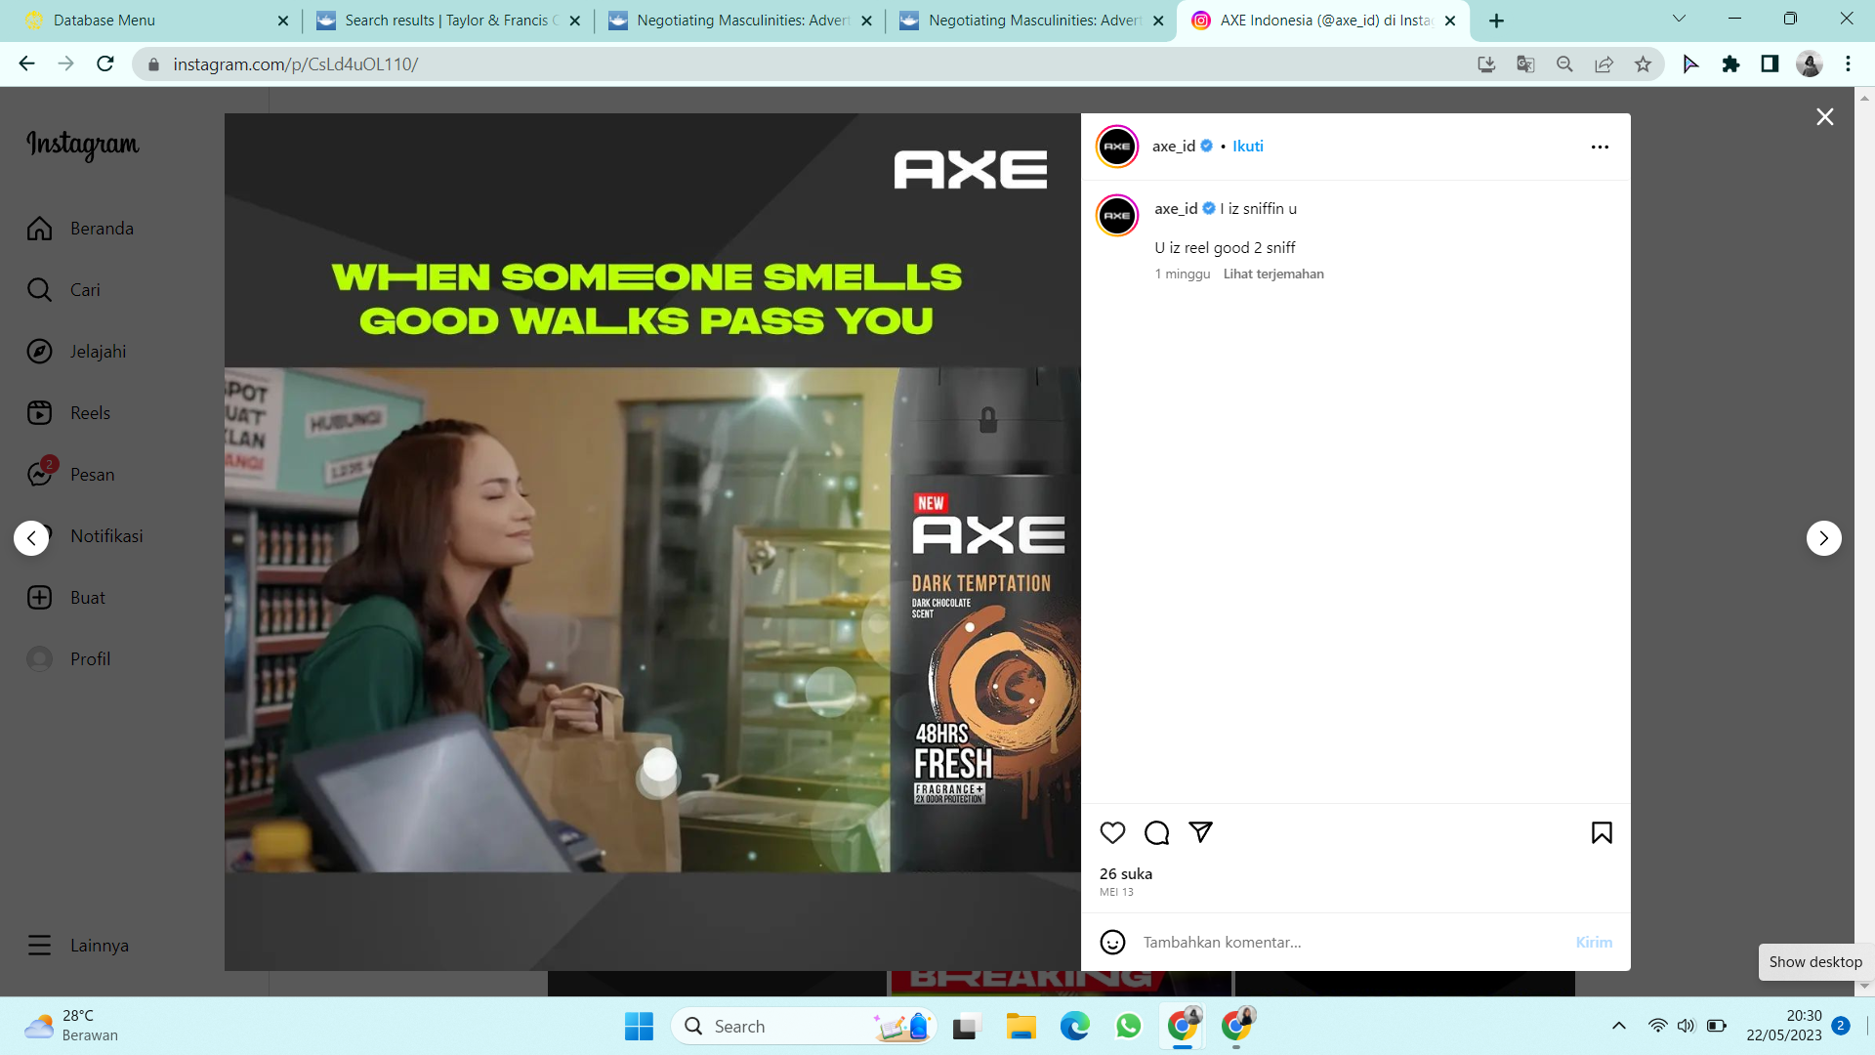
Figure 2. Enzy Storia sniffing fragrance.

Enzy Storia's expression while sniffing the fragrance from a man emphasizes the dominant role of men in attracting women through their scent. Additionally, Enzy Storia is depicted serving customers, which portrays women as objects existing to satisfy the desires of men.
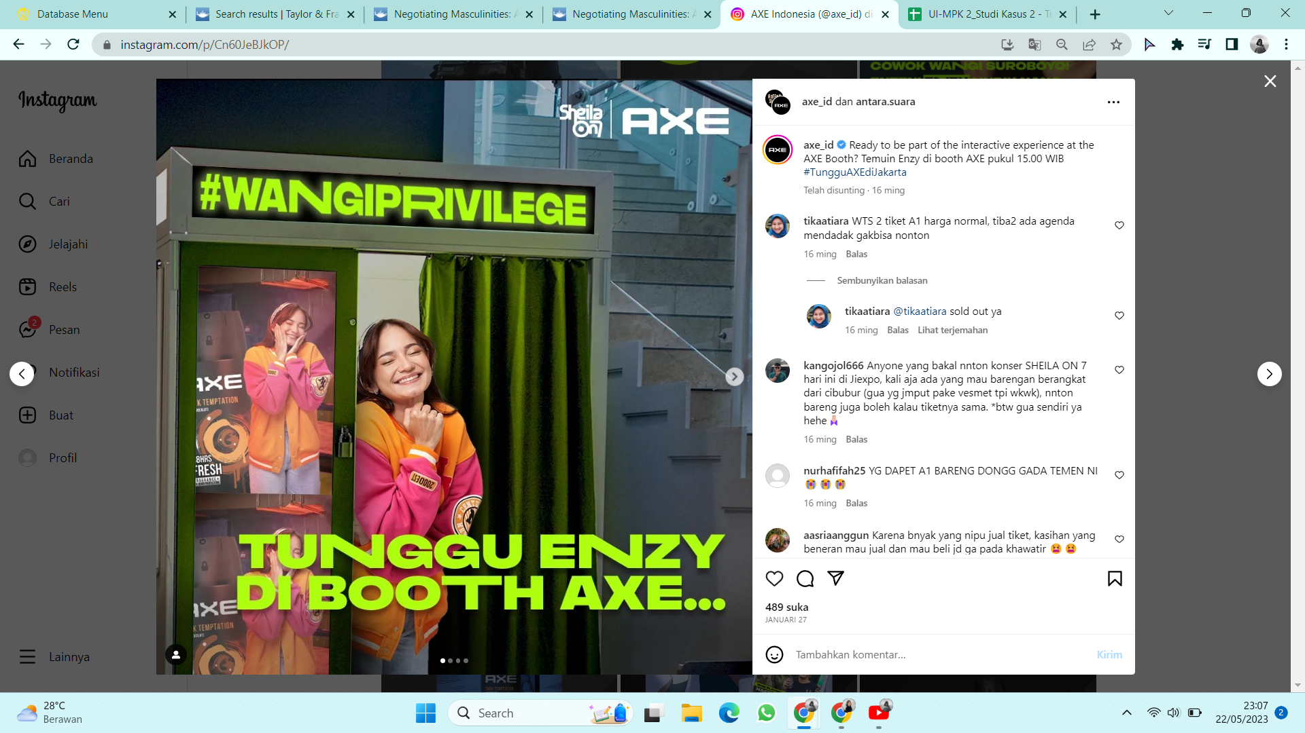
Figure 3. Enzy Storia closes her eyes

The image of Enzy Storia closing her eyes while smiling creates a sensual impression and portrays Enzy Storia as an object responding to the presence of men with pleasure or enchantment. Enzy Storia's presence alongside Axe Indonesia products and her wide smile reinforces the relationship between women and products, wherein Enzy Storia is used as a means to enhance the product's appeal and attract the attention of male consumers.

Figure 4. Enzy Storia is holding hands with a man.

Furthermore, the image of Enzy Storia holding hands with a man, singing with several men, and being surrounded by several men depicts Enzy Storia in a context of intense social interaction with these men. Enzy Storia's central position and her role as the center of attention for men reinforce the perspective of the Male Gaze, wherein women are positioned as objects that can be acquired or enjoyed by men.

Figure 5. Enzy Storia is spraying perfume on a man.

The footage of Enzy Storia spraying perfume on different men also portrays women as providers of pleasure or pursuers of men. This action reinforces the representation of women as objects present to fulfill the desires of men through the use of perfume and attractive physical appearance.
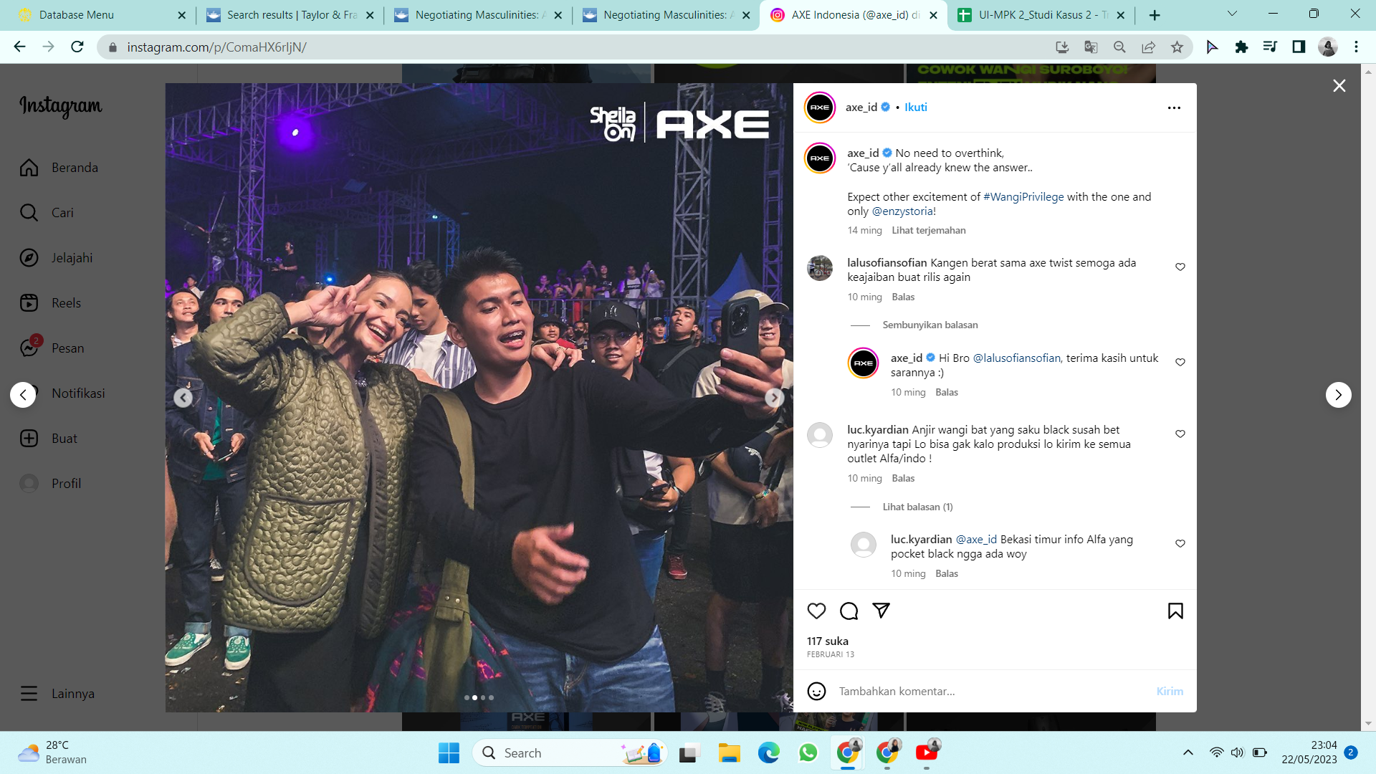
Figure 6. Enzy Storia is taking a selfie with a man and embracing him

Lastly, the images of several different men taking selfies with Enzy Storia demonstrate women as desired objects showcased by men. The act of taking selfies showcases the power and dominance of men in wooing or "owning" Enzy Storia, further emphasizing the construction of women as objects to be possessed by men.
Overall, the visual representation in this collaboration content indicates a strong Male Gaze, where Enzy Storia is depicted as an object existing to fulfill the desires and satisfy the gaze of men. This reflects the traditional role of women in advertising, emphasizing beauty, dependence on men, and the fulfillment of men's sexual desires. This representation further underscores the imbalance of gender power and the objectification of women in the context of internet advertising.

Gender Construction
The analysis of this research also reveals a strong gender construction in the advertisement content. Female artists are often depicted in passive and objective roles, while men are portrayed as dominant and active observers. This portrays a gender hierarchy that reinforces traditional stereotype roles, where women become sexual objects to be viewed, and men as subjects who observe and evaluate. The gender construction in the visual representation of the collaboration content between Axe Indonesia and Enzy Storia on Instagram reveals a consistent framing with the Male Gaze view in advertising. Through the visual displays found, it can be seen how Enzy Storia is represented in the position of an object that is positioned in dependence on men and as a source of pleasure for them.

The expression of Enzy Storia sniffing fragrance from a man indicates women as the party that is aroused or tempted by the presence of men and recognizes the dominance of male fragrance in attracting women's attention. In this context, women are positioned as recipients of sensory pleasure from men, affirming the dominance of men in the interaction process. The image of Enzy Storia serving customers shows women as objects that exist to fulfill the needs or desires of men. Women are depicted in a role that expresses dependence and availability to fulfill the desires of male consumers, conveying the message that they can obtain the desired women by using Axe Indonesia products.

The expression of Enzy Storia closing her eyes while smiling reinforces the male gaze view by highlighting dimensions of sensuality and sexuality. In this representation, women are considered objects that respond positively and seductively to the presence of men, showing a desire to satisfy men's desires through physical attractiveness and sexual appeal. Enzy Storia's presence with Axe Indonesia products and her wide smile connects women with material objects and place them in a relationship that is dependent on the product. This representation emphasizes that women are an essential component in strengthening the attractiveness and image of the Axe Indonesia brand and that their presence only holds value in the context of consumption and use of the product.

Furthermore, the image of Enzy Storia holding hands with a man, singing with several men, and being surrounded by several men reinforces the role of women as objects involved in interaction with men. In this context, women are positioned as the center of attention and attraction for men, emphasizing men's dominance in social interaction situations. The display of Enzy Storia spraying perfume on different men indicates women as givers of pleasure or pursuers of men. This action leads to the view that women are responsible for attracting men through the use of perfume and efforts in physical appearance, conveying the message that women can achieve success in relationships with men through the use of Axe Indonesia products. Lastly, the image of several different men taking selfies with Enzy Storia shows women as objects for men. This action confirms the view that women are objects that can be owned and displayed by men, reflecting an unbalanced gender power relationship in this advertising context.

Overall, the gender construction in this collaboration content reveals a deep understanding of the objectification of women's roles to fulfill the desires and satisfaction of men. This representation strongly reinforces male dominance in the Male Gaze view in advertising, positioning women as available objects, dependent on men, and as sources of pleasure and satisfaction for them. This understanding is crucial for understanding the role and impact of advertising on gender construction and power relations in society.

The Contribution of Enzy Storia
In this collaboration, Enzy Storia also contributes to the existence of the male gaze in the collaboration content of Axe Indonesia on Instagram. It can be seen that Enzy Storia's visual role reinforces representations that are in line with the Male Gaze view in advertising. Through the series of displays found, Enzy becomes an object that supports and reinforces the dominance of the Male Gaze view, as well as exploits gender stereotypes inherent in the role of women in the context of advertising.

The male gaze present in the collaboration between Axe Indonesia and Enzy Storia on Instagram is also supported by audio elements, captions, and copy that objectify women. In the audio of several videos that feature Enzy Storia, it was found that Axe Indonesia uses audio scripts that objectify Enzy. The script directs the audience to "get" Enzy, emphasizing Enzy's search by others, and giving the impression that the presence of a fragrant man will bring women closer. Additionally, Enzy is also positioned as the subject in question highlighting Enzy's desire to have a fragrant man and is used to greet customers. Through these audio elements, there is a reinforcement of the representation of objectification towards Enzy.

In the caption section, there is a significant difference between the coding of objectification and subjectification towards Enzy. Objectification coding is much more dominant in the caption, which positions Enzy as an object that can be "obtained," "sought," or "owned" by others. Captions in Axe Indonesia's posts also emphasize a call to interact with Enzy Storia, collaborate with her, and create fascination with Enzy Storia through her fragrant aroma. On the other hand, the subjectification of Enzy Storia is seen in captions that highlight Enzy's role in giving prizes, searching for a fragrant man, and as the winner of the event.

Furthermore, this collaboration also contains text in visuals that position Enzy Storia as both an object and a subject. The text points to the context of "getting Enzy," "sought by Enzy," and treats Enzy as a crush or daughter-in-law. Additionally, there is an emphasis that Enzy Storia is being served or served by others, as well as an emphasis on the fragrance that brings Enzy Storia closer. However, there is also an emphasis on subjectification by referring to Enzy Storia as a subject looking for a fragrant man and waiting for the arrival of a fragrant man.

This research also found that the visuals displayed in Axe Indonesia's advertising content involving Enzy Storia on Instagram invite various comments from the audience. Some highlighted comments in the study include expectations of meeting Enzy Storia, disappointment and sadness because Enzy Storia did not come to their city, expressions of excitement, the desire to meet and take photos with Enzy Storia, as well as audience actions tagging or mentioning others to show the desire for those individuals to know about the content provided. Thus, Enzy Storia's role in this advertising plays an important role in attracting the audience's attention and influencing their responses. In this context, visuals involving Enzy Storia as the brand ambassador or influencer of Axe Indonesia on Instagram can elicit various reactions from the audience. The audience can respond positively by expressing their desire to meet Enzy Storia or showing their enthusiasm. On the other hand, some also respond with disappointment or sadness because Enzy Storia could not come to their city. In addition, the audience's action of tagging or mentioning others indicates an urge to share the content with others they consider interesting or relevant.
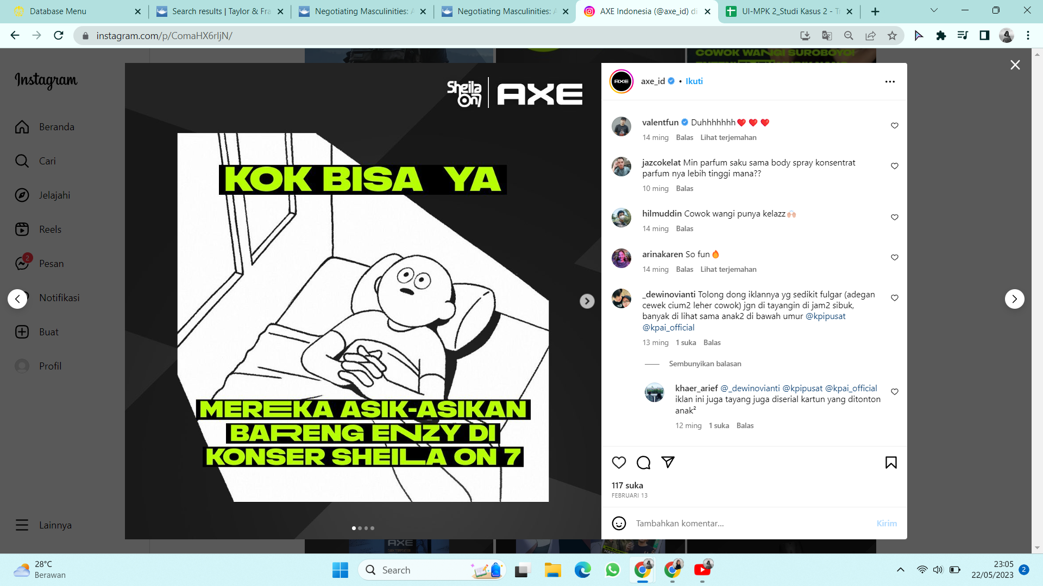
Figure 7. Protest comment

However, there is also a comment expressing protest against the Axe Indonesia commercial aired on television. The commentator considers the advertisement to be too vulgar and regrets the existence of such advertisements being aired during hours when children's cartoons are being broadcast on television. This indicates that the advertisement is deemed inappropriate or not in line with the expected broadcasting context by some viewers.

Research Limitation
The research "Male Gaze in Advertising on the Internet: Content Analysis of Axe Indonesia's Collaboration with Enzy Storia on Instagram" has several limitations that need to be considered. First, this study only focuses on one brand, namely Axe Indonesia, and its collaboration with Enzy Storia on Instagram. Therefore, generalizing the findings of this research to male advertising in general needs to be done carefully, considering the diversity of content and collaborations that may occur on other platforms.

Another limitation is the research method used, namely content analysis. Although this method provides rich insights into the representations and messages contained in advertisements, it does not provide an in-depth understanding of the perceptions and experiences of individuals involved in viewing and interpreting the advertisements. Therefore, this research does not directly involve the perspectives of users or audiences, so this limitation needs to be considered in interpreting the research results.

This study also focuses only on the advertising content of Axe Indonesia, so the research results cannot be directly applied to the advertising context in other countries. Additionally, this study does not analyze in detail the cultural factors that may influence the representation and gender perceptions in the advertising content.

Therefore, there is a need to update the limitations to add to the information obtained in this research. Nevertheless, this research provides an overview and information regarding how the male gaze is reflected in the advertising content of Axe Indonesia involving Enzy Storia on Instagram to gain engagement.

Conclusion
These findings have managerial implications for companies involved in Internet advertising. Advertisers must consider the impact of visual representation and gender constructions in their ad content. It is important to avoid the objectification of women and promote more balanced and inclusive representations. Advertisers also need to understand how the male gaze perspective can affect consumer perceptions and consider its impact on the brand and company image. They need to be aware of their responsibility in creating content that does not reinforce gender stereotypes and objectification of women.

Overall, this study underscores the importance of awareness of the male gaze in internet advertising and the need for measures to avoid the objectification of women and promote more balanced representations. By understanding the theoretical and managerial implications of these findings, companies can play their part in building more inclusive advertising that reflects the diversity of society.

Bibliography
A’yunin, Q., & Triastuti, E. (n.d.). Komodifikasi Kesalehan Niqabis Di Media Sosial Instagram.
Adegbola, O., Gearhart, S., & Skarda-Mitchell, J. (2018). Using Instagram to engage with (potential) consumers: A study of Forbes Most Valuable Brands’ use of Instagram. The Journal of Social Media in Society, 7(2), 232–251.
Anagnostopoulos, C., Parganas, P., Chadwick, S., & Fenton, A. (2018). Branding in pictures: using Instagram as a brand management tool in professional team sports organizations. European Sport Management Quarterly, 18(4), 413–438.
Anderson, S. (2019). Visitor and audience research in museums. The Routledge Handbook of Museums, Media and Communication, 80–95.
Axe. id. (2023). No Title. Facebook. https://www.facebook.com/AXE.ID/about/?ref=page_internal
BAGASAYU, A. M. (2021). Rasisme Dalam Film Comedy:(Analisis Stereotype Film Green Book).
Becker-Herby, E. (2016). The rise of advertising: Authentically reaching female consumers.
Creswell, J. W., & Creswell, J. D. (2017). Research design: Qualitative, quantitative, and mixed methods approaches. Sage publications.
Fadli, Z., Sudirjo, F., Rahmat, R., Deana Santosa, A., S Pasaribu, J., Wahyu Octaviani, D., Sandi Yudha, H., Fauzan, R., Triwijayati, A., & Yanto Rukmana, A. (2023). Manajemen Pemasaran Digital.
Fellows, R. F., & Liu, A. M. M. (2021). Research methods for construction. John Wiley & Sons.
Fowler, K., & Thomas, V. (2015). A content analysis of male roles in television advertising: Do traditional roles still hold? Journal of Marketing Communications, 21(5), 356–371.
Grau, S. L., & Zotos, Y. C. (2018). Gender stereotypes in advertising: a review of current research. Current Research on Gender Issues in Advertising, 3–12.
Huang, J. C. (2021). Gender and celebrity scandals: a cross-cultural examination on celebrity endorsement. Journal of Promotion Management, 27(1), 133–150.
JS, S. M. (2019). Histories, memories, and the male gaze: The Mumbai riots in Bombay. South Asian Popular Culture, 17(2), 159–169.
Lieven, T., & Hildebrand, C. (2016). The impact of brand gender on brand equity: Findings from a large-scale cross-cultural study in ten countries. International Marketing Review, 33(2), 178–195.
Oliver, K. (2017). The male gaze is more relevant, and more dangerous than ever. New Review of Film and Television Studies, 15(4), 451–455.
Patterson, M., & Elliott, R. (2002). Negotiating masculinities: Advertising and the inversion of the male gaze. Consumption, Markets and Culture, 5(3), 231–249.
Roth, A., & Zawadzki, T. (2018). Instagram as a tool for promoting superfood products. Annals of Marketing Management and Economics, 4(1), 101–113.
Segumpan, R. G., & McAlaney, J. (2023). Challenges and Reforms in Gulf Higher Education: Confronting the COVID-19 Pandemic and Assessing Future Implications. Taylor & Francis.
Suh, T., Wilson, R. T., & On, S. (2023). Gender difference in visual attention to digital content of place-based advertising: a data-driven scientific approach. Electronic Commerce Research, 23(2), 877–897.
Sumer, S. I., & Parilti, N. (2023). Social Media Analytics in Predicting Consumer Behavior. CRC Press.
Tian, S., Tao, W., Hong, C., & Tsai, W.-H. S. (2022). Meaning transfer in celebrity endorsement and co-branding: meaning valence, association type, and brand awareness. International Journal of Advertising, 41(6), 1017–1037.

