|  |  |  |
| --- | --- | --- |
|  | **Edunity**  Volume 2 Number 12, December, 2023  p- ISSN 2963-3648[-](http://sosains.greenvest.co.id/index.php/sosains) e-ISSN 2964-8653  Doi:  https://edunity.publikasikupublisher.com/index.php/Edunity/index |  |

**SPECIAL INTEREST TOURISM DEVELOPMENT AT TONGACI BEACH TOURISM, SUNGAILIAT, BANGKA BELITUNG**

**Ruth Soesanto1, Budi Setiawan2**

Universitas Pradita, Indonesia

E-mail**:** ruth.soesanto@student.pradita.ac.id1, budi.setiawan@pradita.ac.id2

|  |
| --- |
| **ABSTRACT**  The tourism sector is one of the largest and strongest sectors in the world economy and is one of the main drivers of the world economy which is able to provide quite a large amount of foreign exchange for the country. One of the fastest growing tourism sectors in the tourism industry is special interest tourism which shows that tourists are starting to demand more varied and stimulating holiday experiences. The aim of this research is to develop special interest tourism in the form of Hatchlings Babel Sea Turtle Conservation in Bangka Belitung which is a conservation site to maintain and minimize the decline in turtle populations, especially in Bangka Belitung waters. The method used in this research is a qualitative method where the data obtained is by conducting direct observations and interviews at the Babel Tukik Conservation. Hatchlings Babel Sea Turtle Conservation is also used as a special interest tourism facility as well as an educational place so that local people and foreign tourists can get to know more about sea turtles and it is hoped that awareness will arise to preserve sea turtles from the threat of extinction and damage to the marine ecosystem due to sea tin mining and illegal hunting  **Keywords:** Special Interest Tourism; Conservation; Turtles; Tongaci Beach; Bangka Belitung |

**Introduction**

The tourism sector is one of the largest and strongest sectors in the world economy and is one of the main drivers of the world economy because there are several benefits that can provide quite large foreign exchange for the country (Sabon et al., 2018). Law Number 10 of 2009, which regulates tourism in Indonesia, covers a wide range of tourism-related activities and is bolstered by a number of community, business, and regional government facilities and services (Chaerunissa et al., 2020). The growth of the tourism industry not only benefits the nation, but it also benefits the community since it allows for a type of reciprocity between the two. With tourism, the community will participate directly in tourism-related activities in an indirect manner (Astari et al., 2023).

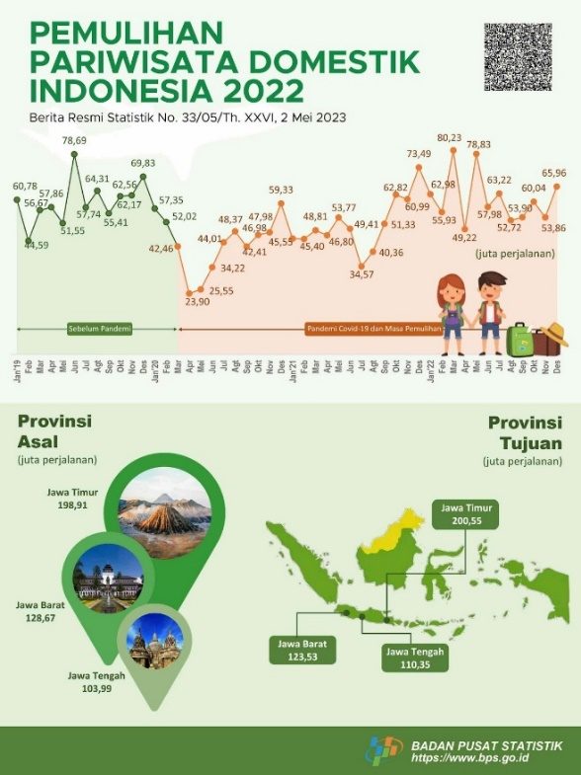

**Figure 1. Indonesian Domestic Tourism 2022, Central Statistics Agency**

As per the Ministry of Tourism's Deputy for Industrial and Institutional Development in 2019, special interest tourism is experiencing rapid growth, indicating that travelers are beginning to seek more diverse and engaging vacation experiences. Special interest tourism is a kind of travel targeted at groups who want to engage with local communities directly through quality experiences and the opportunity to try authentic things (Rahmatia, 2022). According to the book "Special Interest Tourism," the term "special interest tourism" can refer to a variety of special interests, including adventure, culture, cuisine, and others (Bhattacharya, 2018)The province of Bangka Belitung Islands includes Bangka Island, which is home to one of Indonesia's special interest tourism destinations.

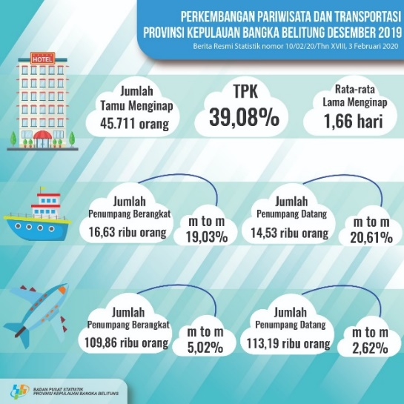

**Figure 2. Provincial Tourism and Transportation Development. Bangka Belitung Islands December 2019, Central Statistics Agency**

Bangka Island is well-known for its abundance of stunning natural tourist destinations, particularly its unique beaches, which astound visitors (Fatimah, 2021). The Bangka Belitung Islands Provincial Government states that the province's combined land and sea areas total 81,725.06 square kilometers (Wati et al., 2022). Compared to other islands, Bangka Island stands out for having sloping beaches with white sand accented by granite patches (Prianto et al., 2017). Tongaci Beach, which was listed as the tenth best beach in the Bangka Belitung Islands, is one of the beach tourist attractions on Bangka Island that is presently being developed (Tripadvisor, 2018).

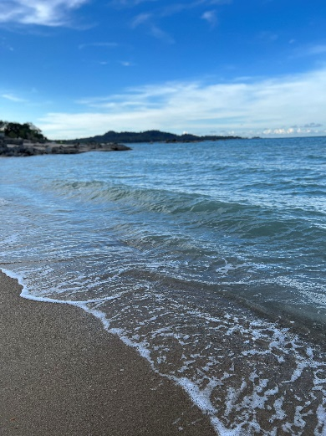Tongaci Beach, which is one of the most well-liked tourist spots due to its fine white sand, clear sea water, and serene atmosphere, is situated on Jalan Laut, Kampung Pasir, Sungailiat, Bangka Belitung. Beyond being a destination for families, Tongaci Beach also provides a range of activities for its guests to partake in by offering a variety of options (Fatimah, 2021). This beach also features an ecotourism concept that is composed of 50% education about turtle conservation, which visitors can do by releasing turtles at the Hatchlings Babel Sea Turtle Conservation, and 50% entertainment in the form of games and community gathering places (Araini, 2017). The Tukik Babel Foundation is a private organization that works to protect and care for turtles in designated conservation areas, such as Tongaci Beach. It also regularly releases turtles back into their natural habitat in an effort to preserve the turtle population's declining numbers (Megawandi, 2020).

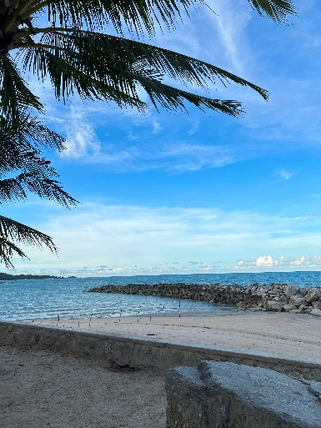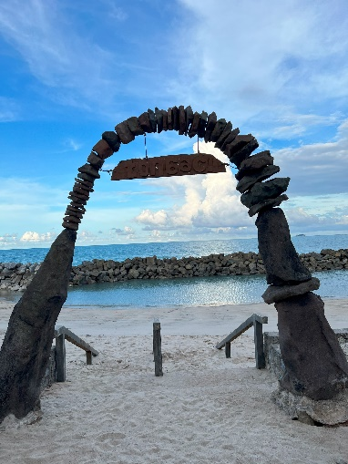

**Figure 3. Tongaci Beach**

According to Ario in (Hamino, 2021), One of the actions that is anticipated to stop the destruction of turtle habitat is conservation. It also aims to stop the use of turtles for commercial purposes and serves as a vehicle for educating the general public about the value of protecting Indonesia's turtle habitat from extinction. Six of the seven species found worldwide are found in the seas off the coast of Indonesia (Fitri et al., 2023). According to the International Union for the Conservation of Nature and Appendix I CITES (Convention on International Trade in Endangered Species), the Leatherback Turtle *(Dermochelys Coriacea)*, Green Turtle *(Chelonia Mydas)*, Hawksbill Turtle *(Eretmochelys imbricate)*, Loggerhead Turtle *(Caretta Caretta)*, Olive Ridley Turtle *(Lepidochelys Olivacea)* and Flatback Turtle *(Natator Sepresus)* are threatened with extinction, so all forms of use and distribution must be given serious consideration. Humans pose the biggest threat to sea turtles because of their enormous commercial value (Tarigan et al., 2020) in addition to the overdevelopment of coastal areas and the widespread illegal hunting of turtle eggs and body parts, which is then preserved for exhibition, all persist to this day (Nur, 2022) additionally, the turtle is classified as endangered because the population of practically every species in Indonesia has declined (Firliansyah et al., 2017).

Intentional or inadvertent captures have the potential to endanger the survival of the turtle population. In addition, young turtle mortality is high, with only one to three of a mother turtle's 100 eggs thought to survive (Soetijono, 2019). Since natural and semi-natural population growth can be said to be close to zero, it is feared that the entire turtle population will be wiped out in the near future. This has led to strong criticism from various international conservation institutions, such as Greenpeace, which stated in its report that the Indonesian government needs to take firm action against violators (Soetijono, 2019). Over the past ten years, several international turtle biologists have examined the state of Indonesian turtles and their utilization, expressing concern over the decline in turtle populations in different areas where they nest (Nuitja, 1997). Deeds of the Minister of Forestry, No. 327/Kpts/UM/5/1978 for leatherback turtles, No. 716/Kpts/Um/10/1980 for Olive Ridley and Loggerhead Turtles, No. 882/Kpts-II/1992 for Hawksbill Turtles, and Government Regulation No. 7 of 1999 for Green Turtles are some of the ways that the Indonesian government has protected turtle populations (Timotius, 1999). The fact that Hatchlings exist Turtle eggs are removed from their natural nests on the beach and placed in Babel Sea Turtle Conservation in Bangka Belitung, a semi-natural hatching site that ensures the eggs hatch safely and without interference from humans or predators. In light of the threat of harm to the marine ecosystem from sea tin mining and illegal hunting, turtle conservation initiatives such as this one are necessary to maintain and minimize the decline in turtle populations, particularly in the waters of Bangka Belitung (Maulana et al., 2017).

**Research Method**

This study was carried out using a qualitative research design. Creswell in Assyakurrohim (2023) defines qualitative research as a kind of study that aims to comprehend the significance of social problems in a variety of individuals or groups of individuals. Since the research is conducted in a natural setting, Sugiyono in Sarafudin (2023) claims that qualitative research methods are frequently referred to as naturalistic research methods. In this study, primary and secondary data sources were consulted. Direct observation at Tongaci Beach, which is situated on Jalan Laut, Kampung Pasir, Sungailiat, Bangka Belitung, was one method used to collect primary data. Administrators of Tongaci Beach were also questioned. Secondary data is gathered from sources such as the most recent literature and documentation that can aid in research.

**Result And Discussion**

Turtles are long-lived animals with superb navigation skills. Large, lung-breathing reptiles, sea turtles are found worldwide in tropical and subtropical waters. With the exception of leatherback turtles, all turtles have two shells: an upper (carapace) and a lower (plastron). The carapace of a turtle is shielded by hard scales (Soetijono, 2019). According to some scientists, turtles can live twice as long as humans (Koernelis, 2016) and as of 2014, the Ministry of Environment reported that there are turtles in Indonesia almost everywhere on the islands, with 143 sites having been identified (Parmi, 2020).

Six of the seven species of turtles found worldwide are found in Indonesia (Habiburrahman, 2023). Government Regulations (Government Regulation No. 7 of 1999 concerning the preservation of plant and animal species, as well as Law No. 5 of 1990 concerning the conservation of biological resources) have designated six types of turtles as protected in Indonesia. These turtles are the following: the Leatherback Turtle *(Dermochelys Coriacea)*, the Green Turtle *(Chelonia mydas),* the Hawksbill Turtle *(Eretmochelys Imbricata)*, the Loggerhead Turtle *(Caretta Caretta)*, the Olive Ridley Turtle *(Lepidochelys Olivacea)*, and the Flatback Turtle *(Natator Sepresus)* (Harnino et al,2021). The Babel Tukik Foundation offers every species of turtle, with the exception of the Flatback Turtle *(Natator Sepresus)*. This turtle travels hundreds or even thousands of kilometers away from its breeding location, giving it a very broad distribution (Harnino et al., 2021).

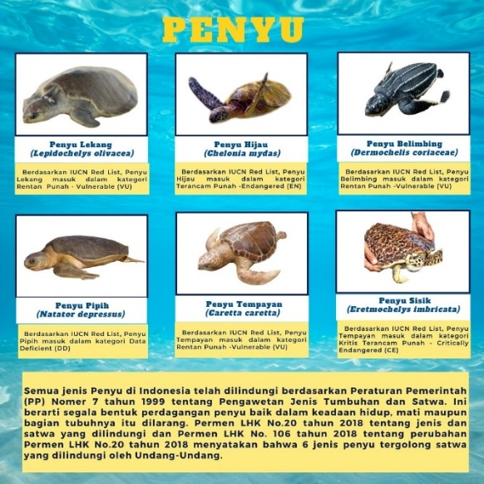

**Figure 4. Types of Turtles in Indonesia Green Turtle (Chelonia Mydas)**

One of the largest turtles, the Green Turtle *(Chelonia Mydas)* has a carapace that can range in size from 71 to 153 cm. Its unique features include an egg-shaped shell that appears smaller from above, a head that is relatively small and blunt, and a body that appears larger than its head, depending on the species' geographic location. The length and width of the carapace of a green turtle vary from 97 to 115 cm and 83.5 to 108 cm, respectively. This turtle has a maximum weight of 205 kg (Utami et al., 2023). They also have appendages on their limbs that are similar to swimming paddles. In addition to having longer tails that protrude outside of their shells, male turtles are bigger than female turtles (Marchello et al., 2023).

**Hawksbill Turtle *(Eretmochelys Imbricata)***

The name "Hawksbill sea turtle" refers to the turtle *Eretmochelys Imbricata*, which has a distinctive beak-shaped snout and an upper jaw that is curved downward and somewhat sharp like a parrot (Rachman et al., 2019). All over Indonesia, hawksbill turtles can be found, but they are most common on tiny, uninhabited islands. From the Riau Islands to Belitung, Lampung, Seribu Islands, Karimunjawa, Sulawesi Sea (Berau), South Sulawesi (Takabonerate) to Southeast Sulawesi (Wakatobi), Maluku, and Papua are home to the majority of hawksbill turtles (Utami et al., 2023).

**Loggerhead Turtle (*Caretta Caretta*)**

Around the world, sea turtles known by the name Loggerhead Turtle *(Caretta Caretta)* can be found in a variety of tropical and subtropical waters. With an average adult weight of 135 kg and a carapace length of 90 cm, this rare turtle is fairly large. The loggerhead turtle has five vertebral scales and four pairs of coastal scales on its hard, reddish brown or yellow-orange carapace. The upper portion of the turtle's neck is brown, while the lower portion (plastron) is a pale yellow color. The habitat and range of loggerhead turtles are extremely extensive, encompassing tropical and subtropical waters in the Atlantic, Indian, Pacific, and Mediterranean oceans (Isdianto et al., 2022).

**Olive Ridley Turtle (Lepidochelys Olivacea)**

The olive ridley turtle, or *Lepidochelys Olivacea*, is the smallest species of turtle that still lives today (Arif, 2023). There is a greater head size and a more angular, slender carapace shape. It has a dull green body that resembles a green turtle. Since there has been relatively little research on Olive Ridley turtles compared to green turtles, little information about Olive Ridley turtles has been gathered, necessitating further investigation into Olive Ridley Turtle existence (Mirna et al., 2021).

**Leatherback Turtle** **(*Dermochelys Coriacea*)**

The elongated back of the leatherback turtle *(Dermochelys Coriacea)* resembles a star fruit. Its head is medium in shape, and its front legs are long. The back of the turtle is almost entirely black with white spots. The leatherback turtle *(Dermochelys Coriacea)* has an elongated back that makes it look like a star fruit. Its front legs are long, and its head is medium in shape. With a few white spots, the turtle's back is nearly completely black (Wiyandhita et al., 2017)*.*

**Habitats**

According to PP Number 28 of 2011 concerning Management of Natural Reserve Areas (KSA) and Nature Conservation Areas, a habitat is an area where plants and/or animals can live and reproduce naturally (Watopa et al., 2021). The primary supporting components of a turtle's living habitat are beaches, sand, temperature, susceptibility to tides, sea level rise, seagrass beds, coral reefs, and coastal vegetation (Alfred et al., 2020). The elements of a turtle's habitat are food, cover and nesting areas, and interactions with other animals (Pratiwi, 2016). Turtle habitats differ depending on the species (Sutisna et al., 2023), For instance, on pebbly and sandy beaches shaded by trees, hawksbill turtles will lay their eggs. On broad, open beaches devoid of tree cover, green and olive ridley turtles will lay their eggs in the interim. Because they are extremely sensitive to light and movement disturbances, turtles prefer calm areas to lay their eggs. If they feel threatened, they will return to the sea (Harnino et al., 2021).

The nesting beach needs to be quiet, dark, and free of strong winds and storms. Aside from that, one distinctive trait of turtles is their reproductive homing behavior, which involves laying eggs on the same beach as they hatch (Septiana et al., 2019). It will be challenging for turtles to find new nesting sites as a result of the loss of beaches. Turtles typically prefer to lay their eggs on a broad, sloping area of land that is above the tide, between 30 and 80 meters, with an average slope of 300 and fine, rocky sand that contains cocretion fractions. Turtles naturally believe that the area is safe to lay their eggs because iron is easy for them to dig up. Tall trees will also give off a feeling of security and act as a unique cue for turtles to lay their eggs. It is quite safe for turtles to come ashore and build egg nests in these conditions (Syam, 2022).

**Turtle Life Cycle**

Turtles grow very slowly, taking decades to reach the age at which they can reproduce (Juliono et al., 2017). Before migrating to mate, adult turtles will spend years in one location. They may travel up to 3,000 km from the feeding area to the nesting beach (Sepawan, 2018). Male and female turtles migrate to their nesting areas near their birth area when they are between 20 and 50 years old. A month or two prior to the season's first nesting, adult sea turtles mate offshore.

When the time for mating arrives, the male turtle will swim after the female after riding her. He will then extend his genitalia in the shape of a backward tail. During mating, the male turtle clamps the female turtle with his front legs to prevent her from easily escaping (Anggas et al., 2022). Turtles will stay in the water for at least six hours, rising and falling to the surface to complete their mating rituals. The female turtle will hold the male's sperm in her body for two months so that it can fertilize and create a nest of three to seven eggs (Wijayanti, 2023). The female turtle will lay hundreds of eggs after this mating. But only 1-3 percent of hatchlings survive to become adults (Harnino et al., 2021).

Two months later, female turtles will return to their birth beach in search of a calm place to lay their eggs. The stages at which different species of turtles lay their eggs typically follow a similar pattern. The stages of the egg-laying process, where the turtle emerges from the breaking waves and heads towards the beach. Subsequently, the turtle ascends onto the shore, remains there for a while, and searches the area for suitable sand to build a nest. The turtle will relocate if it isn't appropriate. The turtle will then use its rear flippers to create a puddle that is 30 to 60 cm deep to support its body. Turtles typically take 45 minutes apiece to excavate a nest and 10–20 minutes to lay their eggs (Pattiwael, 2022) and give the eggs 10 to 20 minutes to hatch in the nest. Eggs are laid by turtles one at a time, occasionally two or three at once (Aliviyanti, 2022). Using its rear flippers, the turtle fills the egg nest with sand. It then uses its four legs to fill the body pit, and it creates a camouflage trail to hide its nesting area. The turtle will then head back out into the ocean in the direction of the breaking waves and vanish between them. Turtles either travel in a straight line or along a winding path when they return to the sea (Anggraini, 2022). After the nesting season concludes, female turtles will go back to their feeding area and won't lay eggs for the following two to eight years.

The eggs will hatch after about 52 days when the remaining yolk has dried, and the hatchlings will hatch after about 7 to 12 weeks. A group of hatchlings must travel for at least two days after hatching in order to reach the sand's surface and determine which way the sea is. They typically do this at night by following the direction that is brightest and making use of the topography of the nearby horizon line. When the hatchlings reach the sea, they use a variety of cues (such as wave direction, currents, and magnetic fields) to help them find deeper offshore areas (Wiguna, 2021). As they approach to mate, the hatchlings' behavior beyond the beach and swimming away is an attempt to document the cues necessary for them to find their way home (Saputro, 2022).

From sustaining healthy coral reef ecosystems to moving vital nutrients from the ocean to the coast, turtles play a critical role in preserving the balance of marine ecosystems (Mulyani, 2018). As ancient reptiles, turtles are susceptible to a variety of disturbances in their lives, including changes in land use that lead to the destruction of coastal habitats from sea tin mining, the death of turtles from fishing activities, poor management of conservation techniques, disease, climate change, the poaching of turtles and their eggs, and the threat of predators. are contributing factors to the decrease in turtle populations (Harnino et al., 2021).

According to (Gazali, 2019), One of the things that is anticipated to stop the extinction of turtle habitat is conservation. It also stops the use of turtles for commercial purposes, like selling eggs, meat, and shells. Additionally, conservation can be a way to educate and spread awareness among the general public about the value of protecting Indonesia's turtle habitat and preventing its extinction. It is hoped that conservation efforts will contribute to the preservation of the turtle population, particularly in the Bangka Belitung region, so that future generations can continue to witness this marine biota. As a region with a large and sufficient amount of coastline coverage to aid in the preservation of turtles in the face of the threat posed by the widespread illegal hunting and sea tin mining that could harm the marine ecosystem. By obtaining knowledge, conducting firsthand observations, and assisting in the release of hatchlings into the open ocean to preserve the number of turtles in the population, the Tukik Babel Foundation can continue to be a popular tourist destination that offers more than just stunning beaches.

**Turtle Conservation**

Preservation is the same as conservation; that is, maintaining the environment's carrying capacity, quality, function, and capabilities in a balanced way (Purmadi et al., 2020). Early awareness is necessary to protect turtles, and conservation is one way to do this (Purwaningsih et al., 2020). A genuine effort or action taken to save, protect, and wisely preserve the environment is known as conservation (Helida, 2019). Realizing the preservation of biological natural resources and their ecosystems in a harmonious and balanced way is one of conservation's objectives (Purmadi et al., 2020).

The field of conservation is one that is flourishing right now and has a lot of promise—not just for the preservation of plants and animals (Harnino et al., 2021). Although many conservation areas are now open to the public as tourist destinations, they still uphold the original goals of the conservation development (Maharani et al., 2016). Chicklings At Tongaci Beach, Sungailiat, Bangka Belitung, special interest tourism offering amusement and education is part of the Babel Sea Turtle Conservation initiative. In addition to learning about environmental preservation, visitors are also educated about the importance of preserving turtle life. On the shores of Tongaci Beach, visitors will adopt one hatchling, which will subsequently be released into the open sea. In addition to releasing hatchlings, there are a plethora of other equally fascinating activities to witness and partake in. These include watching turtles lay their eggs, witnessing hatchlings emerge from their eggs, tending to quarantined turtles, and hearing informative talks about turtles while strolling around the pond and observing the turtles.

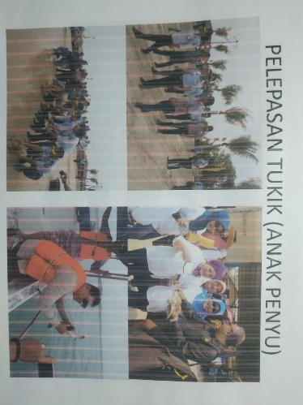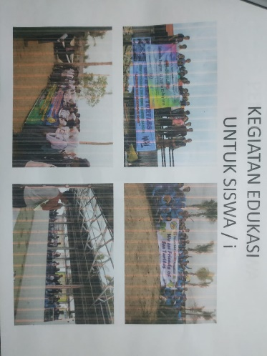

**Figure 5. Release of Hatchlings Figure 6. Educational Activities for into the Sea Students**

Mr. Sian Soegito founded the Babel Hatchling Conservation on May 28, 2009, according to the outcomes of interviews conducted during the observation. A passion for art drove Mr. Sian Soegito to construct Tongaci Beach. As a result, the Museum Gallery and De Locomotief, which house a variety of paintings and antique objects, were built at Tongaci Beach. Since prehistoric times, turtles, particularly hawksbill turtles, have called Tongaci Beach home. Having grown up nearby Tongaci Beach, Mr. Sian Soegito and his family have resided in the region. In addition to the large number of mother turtles coming ashore to lay their eggs, he frequently observed turtles at that time playing and foraging along the shore of Tongaci Beach. But over time, the turtles left our area and fled. One of the reasons is the widespread use of large vessels for tin mining operations at sea, including suction boats, sand dredgers, and human-powered or floating boats. As a result, the marine ecosystem near Tongaci Beach will inevitably suffer harm. This is the reason that Mr. Sian Soegito was motivated to take decisive action and create a turtle conservation area in order to restore the previous state of affairs.

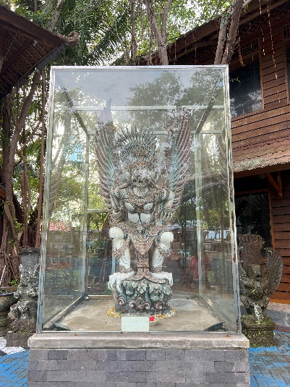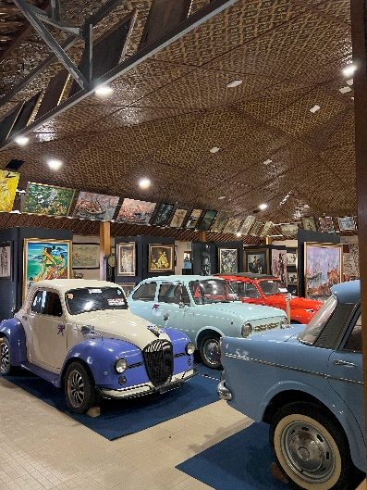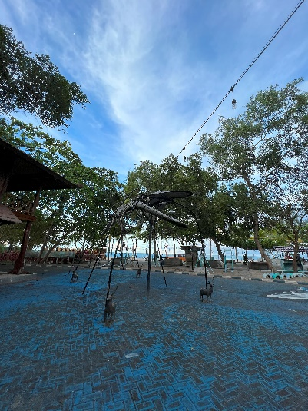

**Figure 7. Figure 8. Figure 9.**

**Whale Skeleton Garuda statue De Locomotive**

**Museum Galleries**

There are two different kinds of pools at the Babel Hatchling Conservation: a large pool for adult turtles and a smaller pool for hatchlings. There are currently 19 adult turtles overall, representing a variety of turtle species. The Babel Hatchling Conservation takes a number of calculated measures to ensure that turtles survive in the wild, such as:

1. Reaching out to anglers and those who fish frequently. Turtles that get entangled in fishing nets or nets must be released in order to protect Babylon hatchlings.
2. Inform the public that if they come across turtle eggs, they should not take or consume them. The eggs must be left for natural hatching in order to preserve Babylonian hatchlings.
3. Assist in the best possible hatching of turtle eggs to produce hatchlings, which will subsequently be released into the water to boost the sea's turtle population.
4. Developing educational initiatives to teach schoolchildren, college students, and organizations how to protect and preserve turtle populations.

The local government continues to support the development of the Babel Hatchling Conservation area, providing administrative and educational support necessary for the smooth operation and expansion of the Hatchlings Babel Sea Turtle Conservation. The hatchlings raised in captivity must be released into the sea right away as soon as they are strong enough, particularly to withstand currents and predators. When the hatchlings, numbering between fifty and one hundred, are three to seven days old, they are released to return to the ocean. Restocking turtles in the wild with hatchlings is one way to keep their population levels stable. Tourists and volunteers from Hatchlings Babel Sea Turtle Conservation participated in the hatchling release event at Tongaci beach in Sungailiat, Bangka Belitung. Usually, the hatchlings should be released in the morning or the evening. Interviews with Hatchlings Babel Sea Turtle Conservation's manager have revealed that turtles are frequently seen in the Bangka Belitung region. The smuggling of 2,287 grains, which the perpetrators allegedly took in the waters of Gelasa Island, Bangka, to be bought and sold so that the general public could consume them, was successfully stopped in June 2022 by the Bangka Belitung police. As was previously mentioned, one of the main dangers facing turtles is human activity. Local communities should be educated about turtle conservation even though there are currently fewer instances of turtle and turtle egg smuggling.

The fact that Hatchlings exist In order to ensure that turtle eggs are safely hatched without being harmed by humans or predators, Babel Sea Turtle Conservation serves as a semi-natural hatching site for turtle eggs removed from their natural nests on the beach. To protect the turtle's habitat, this action was taken as a remedy to prevent people from taking turtles straight out of the water. In addition to serving as a venue for special interest tourism, Hatchlings Babel Sea Turtle Conservation also educates locals and visitors from other countries about sea turtles. It is hoped that this will raise awareness of the need to protect sea turtles from extinction as a result of harm to the marine ecosystem caused by illegal hunting and sea tin mining.

**Conclusion**

The development of special interest tourism at Tongaci Beach, Sungailiat, Bangka Belitung, particularly the Hatchlings Babel Sea Turtle Conservation, was concluded based on the outcomes of the discussions conducted in several previous sections. Releasing An array of turtle species is safeguarded in Indonesia by Hatchlings Babel Sea Turtle Conservation, such as the Green Turtle (Chelonia Mydas), Hawksbill Turtle (Eretmochelys Imbricata), Loggerhead Turtle (Caretta Caretta), Olive Ridley Turtle (Lepidochelys Olivacea) and Leatherback Turtle (Dermochelys Coriacea). To preserve the turtle population in the sea, the turtles are nurtured in the pond, will undergo rehabilitation there in a set amount of time, and then will be released back into the water. Activities offered by the Babylonian Hatchling Conservation include rearing hatchlings in rearing ponds, adopting hatchlings to be released into the sea, and hatching turtle eggs in semi-natural nests. They also have educational facilities. The Hatchlings Babel Sea Turtle Conservation has been successful in educating the general public to support turtle protection, ensuring that this marine biota is preserved for future generations. As a result, turtle conservation is now better than it was. Students are also heavily instructed by Hatchlings Babel Sea Turtle Conservation on how to care for and preserve the survival of turtles. This further qualifies Hatchlings Babel Sea Turtle Conservation as a travel destination of particular interest to travelers.

**Bibliography**

Marchello, R. R., Israhadi, E. I., & Suparno, S. (2023). Analysis of Land Disputes Arising from Land Procurement Activities in the Development of Public Facilities And Infrastructure (Review of Law Number 2 of 2012 concerning Land Acquisition). *Edunity: Social and Educational Studies*, *2*(1), 94–104.